# 1.Write a R program to create a sequence of numbers from 20 to 50 and find the mean of numbers from 20 to 60 and sum of numbers from 51 to 91.

print("sequence of numbers from 20 to 50 is: ")

print(seq(20,50))

print("the mean of numbers from 20 to 60: ")

print(mean(20:60))

print("sum of numbers from 51 to 91")

print(sum(51:91))

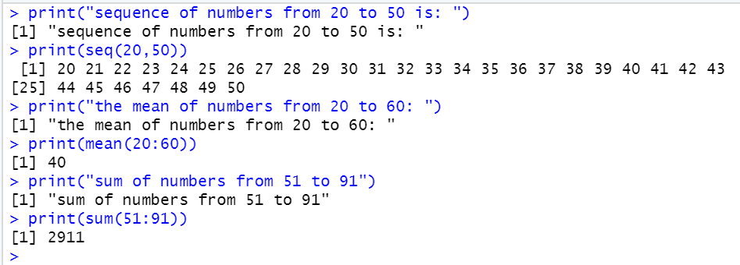

# 2.Write a R program to print the numbers from 1 to 100 and print "Fizz" for multiples of 3, print "Buzz" for multiples of 5, and print "FizzBuzz" for multiples of both.

for(n in 1:100) {

if(n%%3==0 & n%%5==0){print("FizzBuzz")}

else if(n%%3==0){print("Fizz")}

else if(n%%5==0){print("Buzz")}

else (print(n))

}

